|  |  |
| --- | --- |
|  |  |
| Outside Alive Farms |  |
|  |  |
|  | Database for Outside Alive Farms |
|  | Group #1:Thomas Wolf &Max Burzler |

Milestone 1 Recap

Last time for our first presentation we had introduced our 4 different database choices along with their pros and cons and our final decision leading to doing our final project on Outside Alive Farms which is a local plant nursery located in the Myrtle Beach Area.

Introductions

|  |  |
| --- | --- |
|  |  |
| Max Burzler | Thomas Wolf |
| A Networking Systems Administrator Student at Horry Georgetown Technical College and manages presentations, and database. | A Programming Student at Horry Georgetown Technical College and manages documentation, and database. |

Responsibilities

Max Burzler:

* PowerPoint
* Database:
  + Database initial creation and naming.
  + Data types assigned properly.

Thomas Wolf:

* Word Document
* Database:
  + Entitles and Attributes created.
  + ERD created.
  + Data Dictionary created.

Client Updates:

* As Max has worked at the nursery for several years, he was able to produce a starting database that we can show as a start to the project which consisted of seven tables: Inventory, Person, Plants, Purchase, PurchaseDetail, Sale, and SaleDetail and we have also gone in depth with them about all what is within each column in each table.
* After they’ve reviewed the proposed database, they asked if PotSize, and DeliveryStatus can be added.
* The PotSize would play a role within the database as it categorizes the plants by size because it can be the same plant but a different size an example of this would be a 20-gallon, 65 gallon, and 3-gallon size.
* DeliveryStatus is also used to show if the plant has left the nursery or has been delivered and installed on the customers property.

Latest ERD Table

Latest Data Dictionary

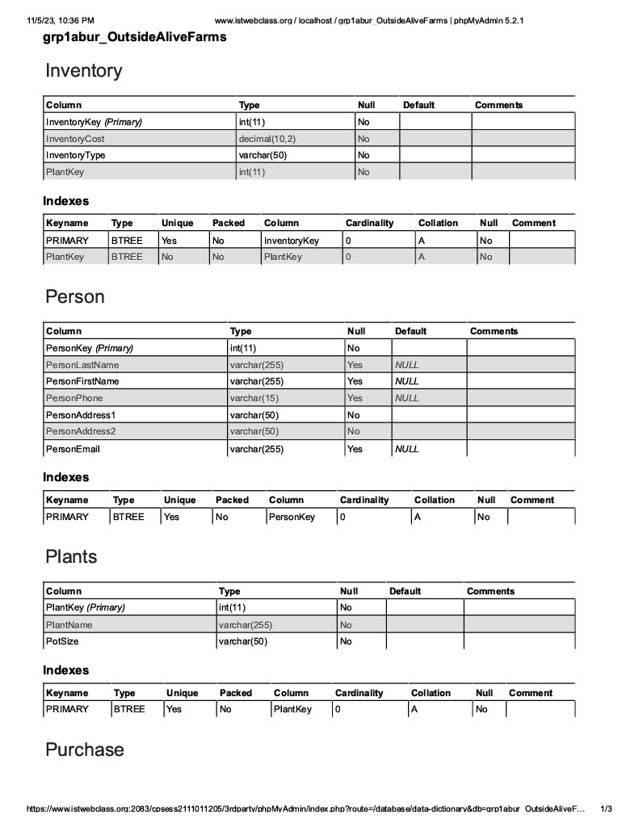

Agenda

To Do by November 19th:

1. Work on the database.
2. Provide insert data into the database itself with sample data.
3. Update the documentation.

Contact Info:

**Max Burzler** [**mburzler@hgtc.edu**](mailto:mburzler@hgtc.edu)

**Thomas Wolf** [**twolf1@hgtc.edu**](mailto:twolf1@hgtc.edu)